

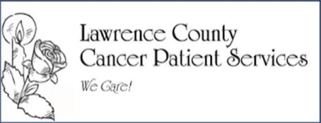
2026

Colon Cancer
Awareness

The Bedford North Lawrence and Mitchell Baseball programs are going to battle it out on Friday, May 8th, in our 12th annual BNL STARS vs. CANCER game held at BNL’s baseball field beginning around 5:30pm. The
Baseball Programs are working together towards a goal of raising over $6,000 this year with all proceeds going to the Lawrence County Cancer Patient Services (LCCPS). We ask that you join us in this great cause and either sign up to be a sponsor, purchase a ribbon, or simply send in a donation.

More importantly, we would like for all those who are currently battling cancer or who are cancer survivors, caregivers, family members to come out and support this heartfelt event. This year, our focus is "Colon Cancer Awareness" (Cancer Ribbon color is Teal) in memory of Scott Saunders, former BNL & Mitchell volleyball coach.

- $300 and up – Your business/family name will be placed on the banner that will be displayed at the event, throughout the rest of the season, and seasons to come. Your business will also be announced as a
sponsor during the game.

- $150-$300 – Your business/family name will be placed on the banner that will be displayed at the event,
throughout the rest of the season, and seasons to come.

- $50-$150 – Your business/family name will be placed on the banner that will be displayed at the event,
throughout the rest of the season, and seasons to come.


We also have an “In Memory of/In Honor of” sponsor section of the banner. For $50, we will honor your friend or family member with his/her respective cancer ribbon in his/her name with your name below that. See image below for 2022 banner.


- Complete Sponsorship Form, making checks payable to: “Lawrence County Cancer Patient Services OR LCCPS.” Cash and Venmo Accepted. Please Venmo the “BNLRBI-Club” with “Cancer Game” in the memo.

- Please submit forms to Jacey Chastain via email, mail, or hand-delivery.
Jacey Chastain
2437 Lucy Lane jaceychastain@gmail.com
Bedford, IN 47421

- We will need all sponsor/donation information and payment by FRIDAY, MAY 1, 2026.

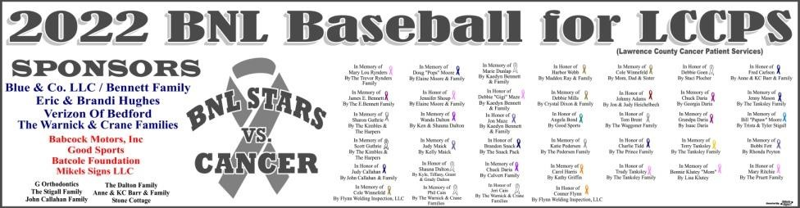

Thank you!

Jacey Chastain

